**Chapter 2**

**Radar Systems and Data**

**2.1 MCoRDS**

The Center for Remote Sensing of Ice Sheets (CReSIS) deployed airborne Multi Channel Coherent Radar Depth Sounder (MCoRDS), a nadir looking radar mounted on an aircraft flying usually at the height of 500 meters from the ice surface to map the thickness of Greenland and Antarctica ice sheets in NASA’s Operation Ice Bridge (OIB) missions [13,19]. This analysis uses the data at Petermann glacier and Jacobshavn glacier from 2008 to 2014 seasons [14]

MCORDS system has evolved over the years and the specifications for each season can be obtained from CReSIS (cresis.ku.edu). MCoRDS operates with linear chirp waveform within the frequency band from 180 MHz to 210 MHz (2012 season). It usually has six transmit channels and receivers to allow beamforming during data processing. An Arbitrary waveform generator (AWG) is used to generate the waveforms which is pre-stored in digital form and converted to analog form using a D/A converter [6]. Three different pulses are used. The short pulses of 1 μs and 3 μs are used to detect the surface and shallow ice layers and doesn’t have high penetration power whereas 10-μs pulse is better in detecting the ice bed as it has higher penetration power. The short and long pulses are alternatively sent with time division multiplexing at pulse repetition frequency of 12 KHz. The received signals are digitized using A/D converters at sampling rate of 111MHz or 150 MHz with 14 ADC bits. Table I. describes some basic radar system parameters.

###### TABLE I. MCoRDS SYSTEM PARAMETERS

|  |  |
| --- | --- |
| **Parameter Description** | **Value** |
| Center Frequency | 195 MHz |
| Bandwidth | 180-210 MHz |
| Transmit Signal Type | Linear Up Chirp |
| Transmit Power | 1050 W |
| Pulse Repetition Frequency | 12 KHz |
| Signal Duration | 1 μs, 3 μs and 10 μs (Low Altitude) 30 μs (High Altitude |
| Transmit Channels | 7 |
| Receive Channels | 15 |
| Noise Figure | 2 |
| Sampling Rate | 111/150 MHz |
| ADC Bits | 14 |
| Data Rate | 32 MB/sec per channel |

The complex data received after processing from this radar without coherent integrations has along track resolution of about 0.5 m and 25m when SAR processed. The resolution in ice is about 4.3 [Gogineni ]. The surface illuminated by the radar or its footprint is important is deriving the surface roughness. For any radar, the footprint bounded by compressed pulse length is given by [11]:

$${\text{D}}_{\text{PL}}\text{=2}\sqrt{\frac{\text{hc}}{\text{∆f}}}$$

where ‘h’ is the height of the aircraft from the surface, Δ𝑓 is the bandwidth of the radar signal. For MCoRDS, the flying height is typically 500 meters and the bandwidth being 30 MHz the radar footprint thus averages around 141 meters for ice surface and for average ice depth of 2000 meters, the footprint is around 316 meters.

## 2.2 Airborne Topographic Mapper (ATM)

Surface roughness calculations are also made from the Airborne Topographic Mapper (ATM), a conical scanning airborne laser developed at NASA Wallops Flight Facility to monitor the earth’s topography. ATM measures the surface frequency of 5 kHz and a scan rate of 20 Hz [18]. The along-track resolution is 3-4 m with laser footprint of ~1m. The primary data product L1B of ATM is QFIT, which is dense surface elevation measurements. It is condensed into ICESSN which fits a plane to the block of points selected at regular intervals (0.5 sec) along track with overlapping of 50% between successive blocks [17]. It also measures the South-North and West-East slope for the plane and RMS fit of the ATM data to the plane. The radar lines of MCoRDS coincide with the track 0 of ICESSN data. ICESSN data has along-track resolution of 80 meters and hence the RMS height from this laser system is calculated by the interpolation for the corresponding radar locations.

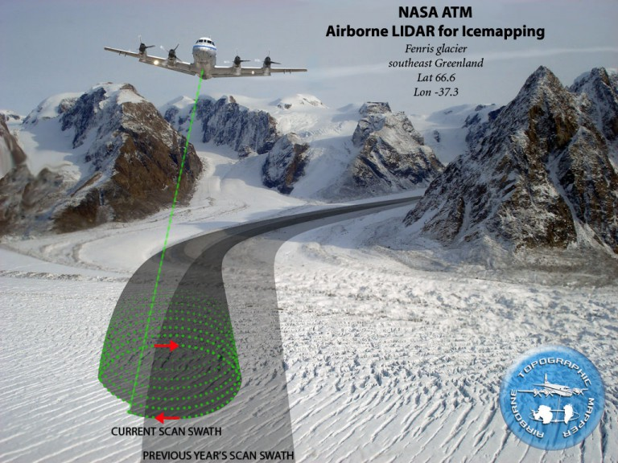

## 2.3 Ku Band Altimeter

Operation IceBridge missions also employ the Ku-band Altimeter developed by CReSIS which is an Ultra Wideband Frequency (UWB) Modulated Continuous wave (FMCW) radar operating usually from 12-18 GHz [19]. It provides high precision surface elevation measurements over polar ice sheets. The along-track resolution of the data from Ku- band is 0.2 meters after hardware presums.